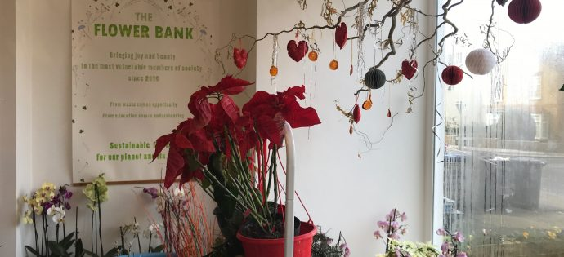

The Flower Bank
There are some big-hearted people out there and none more so than Ursula Stone of The Flower Bank in New Barnet. There’s still time to pop along before Christmas for a nose and to pick up some things to decorate your home or to check out upcoming workshops.
Thanks to a successful crowdfunding campaign, earlier in 2019 Ursula Stone opened The Flower Bank in Leicester Road. She originally set up the enterprise at home repurposing flowers beyond their sell-by date donated by supermarkets and other businesses with plants also donated available for sale. This enables her to supply arrangements to dementia centres, care homes and private customers, as well as occasionally “flower bombing” park benches and other public places (see social media pics below).
Ursula is able to provide low-cost flowers for people on limited incomes – especially for weddings and funerals and she sells flowers and plants (also donated) in the shop for whatever you’re happy to pay (above £3). Rather than so many flowers regularly being wasted, Ursula extends their lives so they can continue giving pleasure and cheer. The therapeutic effect of flowers and plants is becoming widely acknowledged and they have an engaging effect on Alzheimer’s suffers, particularly the colours and fragrance. They can make an instantly uplifting impression.
Ursula Stone trained in floristry at Capel Manor in 2014 after being made redundant as an equality events organiser for Haringey Council. A lot of her work is now with Haringey Young Offenders, teaching them new and satisfying skills as part of their community service. Together they have also created The Flower Bank cutting garden in Tottenham using donated plants whose flowers are used in arrangements. Ursula runs workshops in the shop as well as gardening clubs for the community, creating gardens and flower beds at retirement homes with plans to help other sheltered housing develop kitchen gardens supplying fruit and vegetables.
Here is a piece about The Flower Bank from Channel 5 News (via Twitter).
Check their Facebook page for news and details of upcoming events.
Opening hours
Monday: 2-5pm
Tuesday: 2-5pm
Wednesday: 11am-5pm
Thursday: 2-5pm
Friday: 11am-5pm
Saturday: 11am-5pm
All other times by appointment

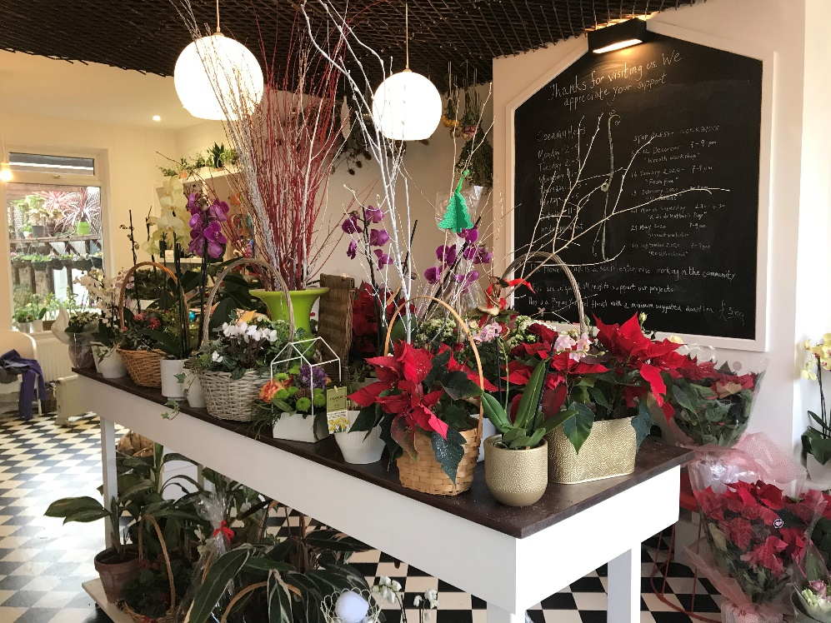
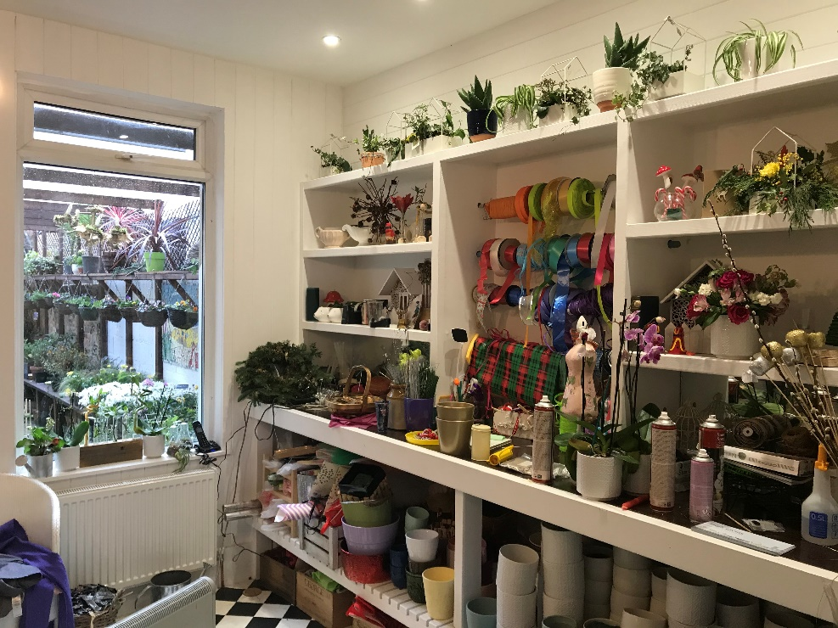
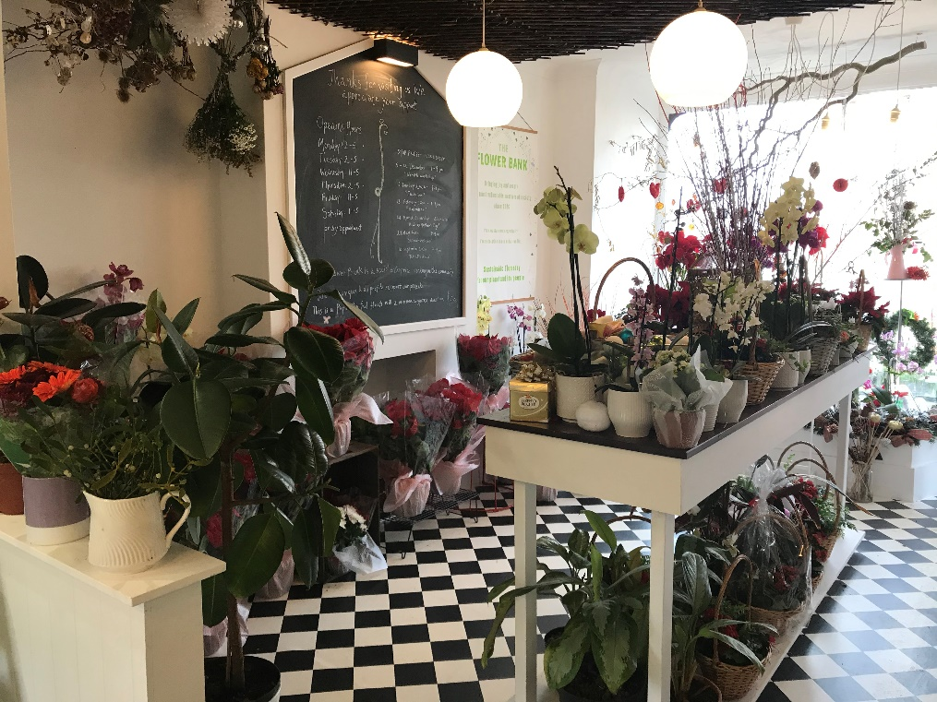
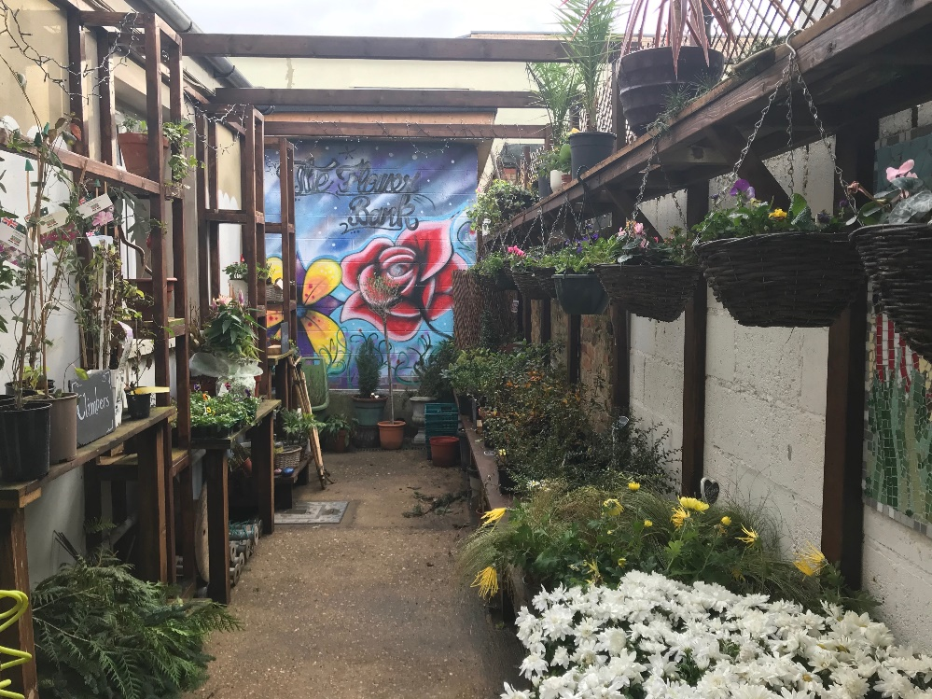
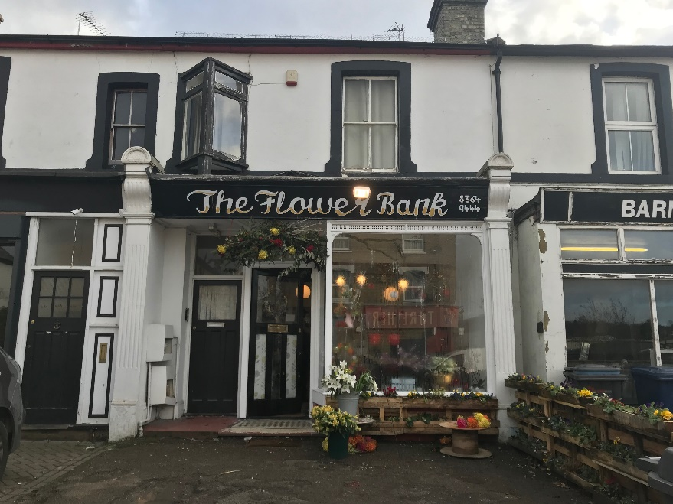
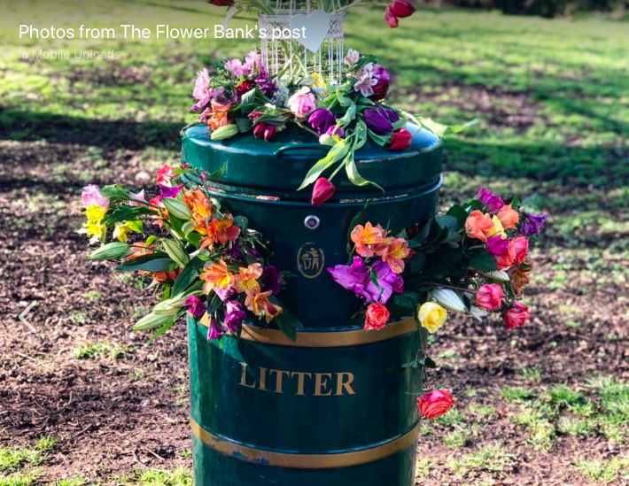
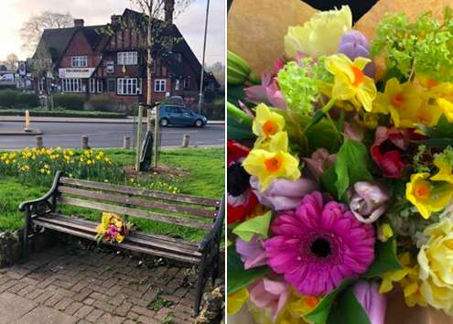
The Flower Bank
45a Leicester Road, New Barnet EN5 5EW
020 8364 9444
www.theflowerbank.org.uk
ursulastone@hotmail.co.uk

